Value Proposition Canvas

The Value Proposition Canvas is a great tool for understanding how customers make decisions, and therefore helps firms in creating offers that are appealing to the end user

Overview
The Value Proposition Canvas (VPC) focuses on understanding customers’ problems and producing products or services that solve them. Telling people you have a great
product doesn’t make them want it. You can produce a brilliant product but if it fundamentally doesn’t help customers, or you don’t explain the value clearly, they won’t buy it.

The VPC is a useful tool that helps businesses decide on the positioning of their product and assists in decision making. The VPC will assist you in identifying the core values of
your offering and will ensure that your product is addressing key issues that are faced by the end user.

Figure 1 below shows the VPC layout, the square and circle respectively represent the value proposition and customer. The circle represents the customer profile and generally,
that is where you should start. The circle is divided into three parts: jobs, pains, and gains. These three areas enable you to think from the end-user perspective when
defining tasks, challenges and desires they’ll have. The square represents the value map and is also divided into three parts, each part relates to the relevant customer profile
section. The focus here is to map out the product features, functionality and benefits that attract customers and fulfill their needs from the circle.

How to fill in the VPC

Here are the steps to complete for your VPC, once you have completed the document please save and upload the file to your SPARKS application via the form. To further assist
you in completing the VPC, please refer to the detailed overview found here: https://www.digitalnatives.hu/blog/value-proposition-canvas/

- Choose a customer segment.
- Identify their jobs and prioritize them according to how important they are to your customer.
- Identify pains and prioritize them.
- Identify their gains and prioritize them.
- Pick the top 3-5 most important pains and gains that relate to the most important jobs.
- List all the benefits of your product or service.
- List all pain relievers.

- List of gain creators.
- Pick 3-5 of the gain creators and pain relievers, that make the biggest difference to your customer.
- Link the pain relievers, gain creators and product benefits to the pains, gains and jobs they solve.
- Define how you’re better than the competition.
- Create various value propositions that are clear and free of jargon and that builds trust with your customers.
- Test your value proposition(s) with your customers

Figure 1
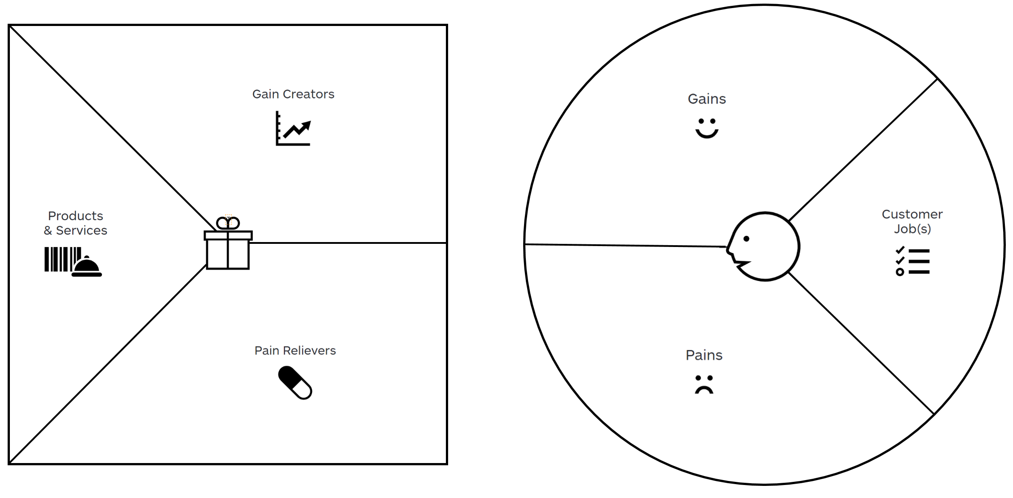

Value Proposition Canvas

Applicant name:
Pain Relievers
Click here to enter text.
Gain Creators
Click here to enter text.
Products & Services
Click here to enter text.
Customer Job(s)
Click here to enter text.
Gains
Click here to enter text.
Pains
Click here to enter text.

